**Getting Started with Python**

Named after the BBC comedy series from the 1970s “Monty Python's Flying Circus”, Python is a general purpose, high level programming language that is used in a variety of application domains. The Python language has a very clear and expressive syntax as well as a large and comprehensive library. Although Python is often used as a scripting language, it can also be used in a wide range of non-scripting contexts. It’s available for all major Operating Systems: Windows, Linux/Unix, OS/2, Mac, Amiga, among others. Python is free to use, even for commercial products, because of its OSI-approved open source license.

**Python 2 or Python 3?**

As of October 2018, Python has two standard versions, Python 2.7 and Python 3.7. However, Python 2.7 is officially being retired on 1 January 2020 and the code from the text is written for Python 3. Therefore, I recommend you use Python 3.7 to complete the assignments.

**Installing Python on Windows**

Linux distributions typically come with Python in the default installation. If you wish to install Python in Windows, go to <http://www.python.org/>. Clicking the Downloads link will present a webpage similar to the Figure 1. Scroll down to Python 3.7.0 and click the download link. Scroll down to the Files section of the new page and click on the version you wish to install. I used “Windows x86-64 executable installer”.

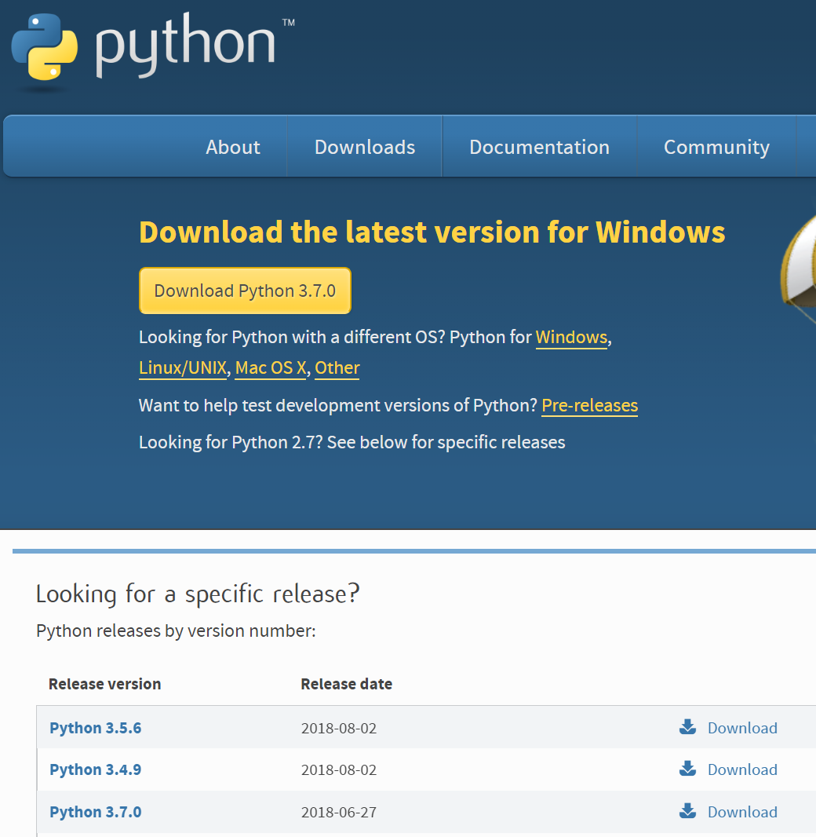

Figure 1. Python webpage showing download link.

1. Double-click the downloaded executable, python-3.7.0-amd64.exe. The name will depend on the version of Python available.

2. I recommend selecting “Install launcher for all users” and “Add Python 3.7 to PATH”.

3. Click Install Now

4. Python is now being installed. You should see Setup was successful at the end.

5. Click Close.

In order to start Python select

Start 🡪 Python 3.7 🡪 IDLE (Python 3.7 64-bit)

You'll see something like the following window. Type **print (“hello”)** to verify Python is running.

